**MIT Energy and Climate Hackathon 2023**

**“Dream Your Biggest Dream”**

**Introduction**

“*America’s forests are in a state of fire emergency. Nearly 25% of the contiguous U.S. is at risk of severe wildfire, with Western landscapes bearing the brunt. The areas at greatest risk are those where forests and communities meet, often referred to as the wildland urban interface. These beautiful locales are where more and more people choose to call home*.” -USFS [Confronting the Wildfire Crisis](https://www.fs.usda.gov/managing-land/wildfire-crisis)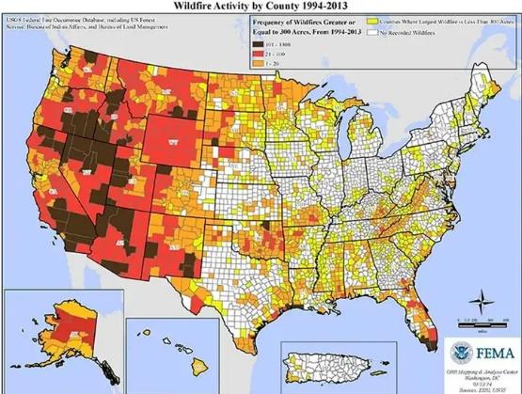

Effectively managing forests on public lands requires that we address managing wildfire while considering the effects of climate change. Of the forested land in the US, 31% is federal land managed by U.S. Forest Service, the Bureau of Land Management, the National Park Service, and the U.S. Fish and Wildlife Service. Management of public lands must be a key component in addressing an uncertain future. On the right, compare the map of fire activity (1994-2013) with the map of federal land.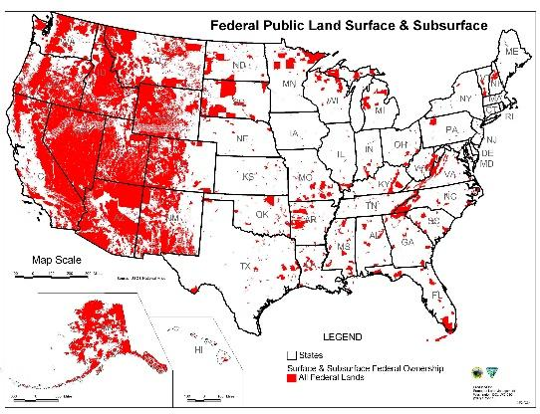

Forests serve as crucial carbon sinks, but the escalation of megafires—created by past management practices—turns these sinks into carbon sources, undermining efforts to curb greenhouse gas emissions. The remedy lies in reimagining public land management, despite its complexities.

Proactive strategies, such as controlled burns and forest restoration, are essential to mitigate wildfire risks and maintain forests' carbon storage capacities as well as restore healthy forest conditions. Furthermore, healthier, more resilient forests can better withstand the stresses of a changing climate. Public lands are not just landscapes to be preserved; they are active components in our climate response. Although managing these vast areas is a daunting task, it remains a vital component of a holistic climate strategy.

**Brief History of Forestry in the Southwestern United States**The history of forestry in the Southwestern United States has played a significant role in shaping the current landscape, often predisposing the region to the megafires we witness today. This history is a tapestry woven with the threads of land management practices, fire suppression policies, and cultural changes in land use that have cumulatively altered the natural fire regimes.

In the late 1800s and early 1900s, the advent of the railroad and the mining boom brought about a surge in demand for timber and cattle, leading to extensive logging of the old-growth forests that were once widespread across the Southwest and then grazing of these same areas. Both of these practices not only reduced the number of large, fire-resistant trees but also changed the vegetative structure of the landscapes, creating more homogeneous landscapes that were more susceptible to the spread of stand replacing fire.

Early in public land management, lack of understanding of ecosystem dynamics led to misguided approaches to fire management. Managers believed that wildfires threatened valuable timber resources and needed to be suppressed. Actually, fires are a natural part of many ecosystems and serve to thin trees, clear underbrush and promote tree regeneration. Over time, lack of natural fires led to an accumulation of dense undergrowth, and an overabundance of smaller trees — what we refer to as ladder fuels — underneath an even more crowded overstory, which can lead to high-severity crown fires.

Simultaneously, the Southwest saw a reduction in the practice of cultural burns by Indigenous peoples, whose knowledge and controlled use of fire had historically maintained a more open and patchy landscape that was resistant to large-scale fire events. The exclusion of these low-intensity fires allowed for an unnaturally dense forested landscape to develop.

As we progressed into the 20th century, with continued fire suppression and a shift from rural to urban land uses, the ecological debt continued to build. The forests became increasingly dense, and the natural fire cycle was further disrupted. When fires did occur, they were often of a much higher intensity and scale than what would have occurred under a natural fire regime.

Today, these conditions, coupled with a century of fire exclusion and past management practices, have set the stage for the megafires we experience. These fires are characterized by their large size, high intensity, and the speed at which they spread, often exacerbated by the build-up of fuels on the forest floor and the continuous canopy that allows fires to travel swiftly across the landscape.

**Four Forest Restoration Initiative**

[The Four Forest Restoration Initiative (4FRI)](https://tnc.maps.arcgis.com/apps/Cascade/index.html?appid=fbd4e42f6f4b4d749ab924f0faacf59c) is a collaborative, multi-stakeholder effort to [restore](https://eri.nau.edu/wp-content/uploads/2019/05/FAQ-Backgrounder-MAY-2019.pdf) the resilience and ecological function of forests across four national forests in northern Arizona, spanning millions of acres within the largest contiguous ponderosa pine forest in the world. Launched in 2010, this initiative aims to address tree densities, forest health, and fire risk through landscape-scale thinning and prescribed burning. The goal is to reduce the threat of catastrophic wildfires while also creating sustainable ecosystems within fire-adapted forest communities. 4FRI is one of the most ambitious restoration projects in the nation, focusing on landscape-scale improvements to forest structure and health, which in turn improve and restore wildlife habitat, water quality, and local economies.

4FRI has encountered several challenges since its inception. These problems include bureaucratic delays, funding shortages, and difficulties in scaling up operations to meet the vastness of the project's goals. There have also been complexities in coordinating among the diverse set of stakeholders and in executing the large-scale thinning operations required. Additionally, the limited capacity of local industry to process the small-diameter (<12”) timber, which is a byproduct of thinning, has posed significant logistical hurdles. These issues have slowed the progress of the initiative, leading to concerns about its ability to effectively reduce the risk of catastrophic wildfires and achieve its long-term ecological restoration objectives.

**Challenges Facing Southwestern Forest Restoration**  
While ambitious and pioneering in its scope, 4FRI encounters several significant challenges that illustrate the complexity of large-scale ecosystem management.

*Inconsistent Supply of Raw Materials:* A critical element in the restoration process is the thinning of overgrown forests, which generates a large volume of small-diameter trees and woody biomass. The ability to move these materials efficiently from forests to processing facilities is crucial. However, the industry currently lacks the infrastructure and capacity to handle these materials consistently, which can impede the pace of restoration work.

This is exacerbated by an [uncertain supply](https://www.paysonroundup.com/government/logging-industry-on-the-brink/article_ce113780-2474-58a6-b2a9-10bdf5194cac.html) of fiber over time. Several efforts have been made to engage in 10- or 20-year contracts, but these efforts have largely failed. Currently, even next quarter projections for upcoming timber sales are not met with confidence. Without a guaranteed supply, mills cannot make the necessary investments in tooling their mills appropriately to maximize value of small diameter trees.

*Dependence on Forest Product Markets:* The economic model of 4FRI is partially predicated on the sale of timber and other forest products derived from restoration activities. However, unforeseen difficulties, turbulent markets, and lack of infrastructure have resulted in increased costs. Timber sales are not “paying their way out of the woods”, as was anticipated.

*Infrastructure Challenges:* Adequate roads and transportation networks are essential for moving biomass. Many of the areas requiring treatment are remote with limited access, which complicates logistics and increases costs. Moreover, there is a shortage of facilities capable of processing the low-value wood, which creates bottlenecks in the supply chain.

*Workforce Limitations:* A skilled workforce is essential for all aspects of forest restoration, including project planning, layout, and execution. The lack of a steady supply of labor—especially skilled machine operators, truck drivers, and forest management professionals—poses another significant hurdle. The seasonal nature of forest work, high cost of living, and the rural location of many projects exacerbate these workforce challenges.

*Regulatory and Permitting Delays:* Complex regulatory frameworks govern forest management and can lead to delays in permitting for thinning and other restoration activities. These delays affect the timing and availability of materials for processing and sale, leading to supply chain inconsistencies.

*Logistical and Operational Complexities:* The vast area covered by the 4FRI presents daunting logistical challenges. Coordinating restoration activities across approximately 2.4 million acres involves complex planning to prioritize areas for treatment, manage workforce and equipment logistics, and mitigate the impact on local communities and the environment.

*Environmental Concerns and Scientific Uncertainties:* Restoration must balance the removal of trees to reduce fire risk with the preservation of habitat for species that rely on dense forests. There are also uncertainties related to the [ecological outcomes](https://drive.google.com/drive/folders/1q_P4gKxChHPp0h52L9eG_-GAmZOHx2G3?usp=drive_link) of restoration activities, and the effects of climate change further complicate predictive models.

*Collaborative Decision-Making:* 4FRI’s collaborative framework is both a strength and a challenge. Reconciling diverse stakeholder interests, from environmental groups to timber companies, requires finding common ground on contentious issues. Delays in decision-making can occur due to the complexity of reaching consensus among so many parties.

**About Ironwood Forestry**

Ironwood Forestry, LLC, is an independent company delivering field support for forest restoration, operating primarily through contracts with the U.S. Forest Service and their partners. Our work primarily focuses on planning and preparing restoration projects (referred to as timber sales), which are essential for maintaining the health and sustainability of forests. Ironwood Forestry stands out for its innovative approaches, merging cutting-edge technology with traditional field forestry methods to enhance the timber sale preparation process.

*Mission Statement:* To find effective solutions for forest restoration in the Southwest through innovation, partnership, and workforce development.

Ironwood Forestry is not a forestry technology company, nor is it any longer just a traditional support services company. We are a solutions and idea company. Our innovations range from more efficient hardware to software development and technological integration. We leverage our curiosity of new technology and methodologies with our experience and knowledge of classic “boots on the ground” forestry to identify solutions where others can’t. A summary of our innovation timeline can be found [here](https://www.ironwoodforestry.com/about/).

On October 26, 2023, Ironwood Forestry was issued a purchase order from the Arizona Department of Forestry and Fire Management to deliver efficiencies and innovations on a full scale 3,250 acre restoration project, titled the Pumphouse Cross Boundary Restoration Project. This is an evolution of our 2021 pilot project on the Southside Airport Timber Sale (see video below)

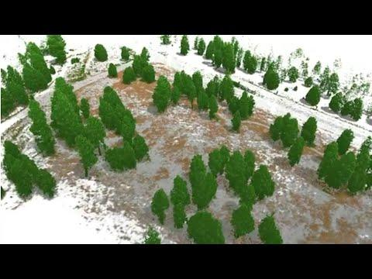

A major deliverable for this project is high resolution and colorized mobile LiDAR scanning across the entire project. This isn't just a survey; it's a groundbreaking 100% tree-by-tree census that has the power to change the landscape of conservation and land management. The primary goals for this project are:

1. Data for Managers - 100% census level data on the residual post-harvest forest, ensuring the silvicultural prescription and ecological goals have been met with precision.
2. Data for Industry - 100% census level data on harvest trees, providing industry with complete confidence in supply.
3. 4D Forest Modeling – A hyper-realistic visualization of the forest in the future, giving certainty of outcome to the public and stakeholders ([low resolution example](https://drive.google.com/file/d/1U0qpuWUM904pLja2DoUKwt72waA-RxMU/view?usp=sharing)). Not only is this breaking into the 4th dimension (time) of modeling, it is looking forward in time, not back. We are calling this “The Forward Dimension.”

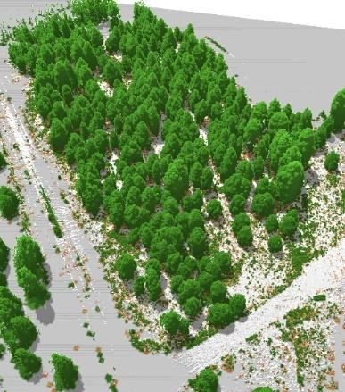

*Current conditions Trees marked for harvest Future conditions*

We already are exploring immediate applications utilizing these datasets. Upcoming on our program of work:

*AR Tree Marking* – We will eliminate the need for tree marking paint altogether. Augmented Reality tree marking will enable a forester to designate trees for retention or removal through an AR platform. This will be communicated to loggers through a similar view only AR platform. This will save significant resources currently spent marking and remarking projects, and increase our capacity to prepare more acreage for restoration.

*AI Enhanced Marking Guides* – Once projects are digitally mapped on the individual tree level and the need for paint is removed, Artificial Intelligence can be used to layout projects automatically simply by inputting desired outcomes. Project outcomes can be visualized given different management goals and finalized by a forester in the field.

*Integration of Gaussian Splat* – Colorized LiDAR is amazing, but no comparison to newly developed [NeRFs and gaussian splats](https://lumalabs.ai/). While in its infancy now, we’re confident that these new ways to model the environment will integrate with our landscape level data sooner rather than later.

We believe we are on the brink of a major breakthrough in land management. Even if we fail in this attempt, this idea is inevitable. This project provides an unprecedented opportunity to innovate – and to imagine the future. The potential applications are unbounded, and we’re inviting you to be a part of this leap in land management.

**Challenge Statement**

We’ve uploaded LiDAR datasets [here](https://drive.google.com/drive/folders/1nMuOqwwCamZhmiGI88ZkaWMpN9pU3P8e?usp=sharing).

Using these datasets, dream your biggest dream and imagine what can be done with census level tree data derived from mobile LiDAR. We’re looking for ideas that may previously have been considered impossible, but maybe are no longer so. We’ve provided some examples above of where we think this can go, but we want to hear your ideas.

Develop your idea into an implementable solution that addresses the challenges facing forest restoration.

Your idea may address technical needs, stakeholder engagement, data management, or any of the needs described. You might even address a problem we haven’t identified! It could be a simulator, a training program, a new tool, or anything else you might imagine.

Dare to dream big with us. Together, let's redefine what's possible in public land management.

**Deliverable Guide**

We recognize that any single idea could be developed into an entire program of work. We are looking for just a ***seed*** of an idea. Do the best you can with the time available. The below information is just a ***guide*** to help you develop your pitch.

1. **Conceptual Framework:**
   * A clearly articulated vision of the proposed solution, including its scope, intended impact, and relevance to the 4FRI goals.
   * An outline of the proposed solution's components and how they integrate with current restoration practices.
2. **Preliminary Design:**
   * Initial designs or blueprints that detail the technical aspects of the solution, including any software, hardware, or logistical systems.
   * Visual aids such as sketches, diagrams, or conceptual models that help illustrate the proposed solution.
3. **Proof of Concept:**
   * A basic prototype or model that demonstrates the core functionality or a key aspect of the proposed solution.
4. **Feasibility Analysis:**
   * An overview of the economic, technical, and operational feasibility of the solution, including potential challenges and risks.
   * Evidence of consideration of the solution's sustainability and long-term viability.
   * An outline of barriers to entry for potential users
5. **Implementation Plan:**
   * A step-by-step plan that outlines how the solution could be developed into a full-scale operational system.
   * Milestones and metrics for success that provide a clear path from concept to reality.
6. **Stakeholder Engagement:**
   * Identification of key stakeholders and a plan for how to engage them with the proposed solution.
   * A communication strategy that includes both technical and non-technical audiences.

**Questions to Guide You**

1. **Problem Identification:** What pressing issue in public land management will your project address?
2. **Solution Relevance:** How will your solution use the LiDAR data to tackle the identified issue?
3. **Solution Impact:** What tangible benefits will your solution bring to land management or conservation?
4. **Innovation and Creativity:** How does your approach introduce innovative or creative use of LiDAR data?
5. **Technical Viability:** Is your proposed solution technically feasible with current technology and resources?
6. **Implementation Strategy:** How do you plan to implement your solution in a real-world setting?
7. **Scalability:** Can your solution be scaled to different sizes or types of landscapes and ecosystems?
8. **Interdisciplinary Approach:** Does your solution integrate knowledge from different fields or disciplines?
9. **Sustainability:** How will your solution contribute to the long-term sustainability of land management practices?
10. **User Engagement:** How will you ensure that the end-users, such as land managers or conservationists, can effectively use your solution?

**Supporting Documentation**

[ERI Forest Restoration FAQ](https://eri.nau.edu/wp-content/uploads/2019/05/FAQ-Backgrounder-MAY-2019.pdf)

[TNC 4FRI Storymap](https://tnc.maps.arcgis.com/apps/Cascade/index.html?appid=fbd4e42f6f4b4d749ab924f0faacf59c)

[USFS 4FRI Website](https://www.fs.usda.gov/4fri)

[4FRI Stakeholder Website](https://4fri.org/)

[USFS Article on Forest Restoration](https://www.fs.usda.gov/features/restoration-can-reduce-risk-and-reduce-wildfires)

[[AZ] Logging Industry on the Brink](https://www.paysonroundup.com/government/logging-industry-on-the-brink/article_ce113780-2474-58a6-b2a9-10bdf5194cac.html)

[Letter and Report from CBD on the Jacob Ryan Timber Sale](https://drive.google.com/drive/folders/1q_P4gKxChHPp0h52L9eG_-GAmZOHx2G3?usp=drive_link)

[RMRS GTR 310 “The Bible”](https://www.fs.usda.gov/rm/pubs/rmrs_gtr310.pdf)

[Confronting the Wildfire Crisis](https://www.fs.usda.gov/managing-land/wildfire-crisis)

**Potential Software**

* LiDAR 360
* Vision LiDAR
* [LidR](https://cran.r-project.org/web/packages/lidR/index.html)
* [Helios](https://github.com/3dgeo-heidelberg/helios)
* [CloudCompare](https://www.danielgm.net/cc/)
* [Forest Vegetation Simulator (FVS)](https://www.fs.usda.gov/fvs/)
* [Forest Vegetation Simulator “Essential User Guide”](https://www.fs.usda.gov/fmsc/ftp/fvs/docs/gtr/EssentialFVS.pdf)
* [Forest Vegetation Simulator “Fire and Fuels Extension” User Guide](https://www.fs.usda.gov/fmsc/ftp/fvs/docs/gtr/FFEguide.pdf)
* [IFTDSS Home Page](https://iftdss.firenet.gov/landing_page/)
* [IFTDSS Overview](https://iftdss.firenet.gov/landing_page/about.html)
* [IFTDSS Sample Output](https://drive.google.com/drive/folders/1VzYg-jWZxlDg8p-Yardl9OgcZLy1w8GK?usp=drive_link)